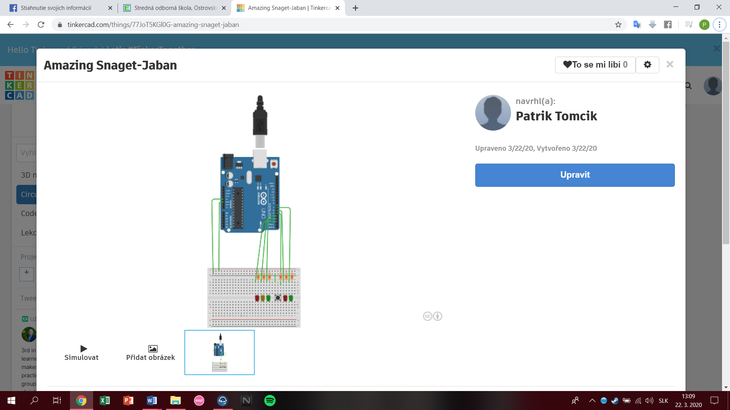

int button = 5;

// AUTO

int cervena = 2;

int zlta = 3;

int zelena = 4;

// CHODEC

int cervenaCH = 6;

int zelenaCH = 7;

void setup(){

pinMode(cervena, OUTPUT);

pinMode(zlta, OUTPUT);

pinMode(zelena, OUTPUT);

pinMode(zelenaCH, OUTPUT);

pinMode(cervenaCH, OUTPUT);

pinMode(button, INPUT);

}

void loop() {

if (digitalRead(button) == HIGH){

delay(15);

if (digitalRead(button) == HIGH) {

changeLights();

delay(3000);

}}}

void changeLights(){

digitalWrite(zelena, HIGH);

digitalWrite(zlta, LOW);

digitalWrite(cervena, LOW);

digitalWrite(cervenaCH, HIGH);

digitalWrite(zelenaCH, LOW);

delay(3000);

digitalWrite(zelena, LOW);

digitalWrite(zlta, HIGH);

digitalWrite(cervena, LOW);

digitalWrite(cervenaCH, HIGH);

digitalWrite(zelenaCH, LOW);

delay(3000);

digitalWrite(zelena, LOW);

digitalWrite(zlta, LOW);

digitalWrite(cervena, HIGH);

digitalWrite(cervenaCH, LOW);

digitalWrite(zelenaCH,HIGH);

delay(4000)

digitalWrite(zelena, LOW);

digitalWrite(zlta, HIGH);

digitalWrite(cervena, HIGH);

digitalWrite(cervenaCH, HIGH);

digitalWrite(zelenaCH, LOW);

delay(2000);

digitalWrite(zelena, HIGH);

digitalWrite(zlta, LOW);

digitalWrite(cervena, LOW);

digitalWrite(cervenaCH, HIGH);

digitalWrite(zelenaCH, LOW);

delay(3000);

}